ASSIGNMENT 1:
Module 2: Basic Python Concepts

Task 1: Perform Basic Mathematical Operations
Problem Statement: Write a Python program that does the following:
1. Takes two numbers as input from the user.
2. Performs the basic mathematical operations on these two numbers:
o Addition
o Subtraction
o Multiplication
o Division
3. Displays the results of each operation on the screen.
Expected Output:
The output should include the result of each operation performed, for example:
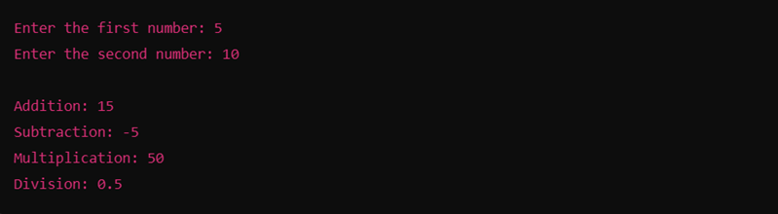
Code: Task 1:

num1 = input("Enter a 1st positive number")
num2 = input("Enter a 2nd positive number")
result_add = int(num1) + int(num2)
result_sub = int(num1) - int(num2)
result_mul = int(num1) * int(num2)
result_div = int(num1)/int(num2)
print("Addition of two numbers is ", result_add)
print("Subtraction of two numbers is ", result_sub)
print("Multiplication of two numbers is ", result_mul)
print("Division of two numbers is ", result_div)
Output:
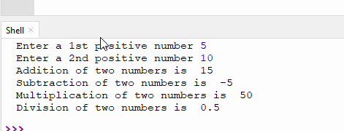

Task 2: Create a Personalized Greeting
Problem Statement: Write a Python program that:
1. Takes a user's first name and last name as input.
2. Concatenates the first name and last name into a full name.
3. Prints a personalized greeting message using the full name.
Expected Output:
The program should output a greeting like:
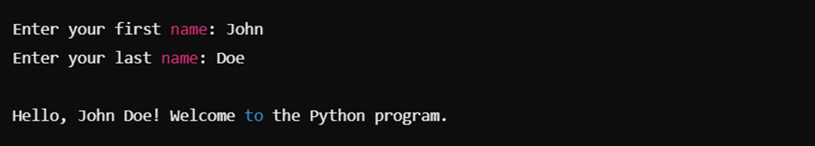
Code:
firstname = input("Enter your first name")
secondname = input("Enter your last name")
result = str(firstname + secondname)
result2 = "!"
print("Hello,",result+result2,"Welcome to the Python program.")

Desired Output:
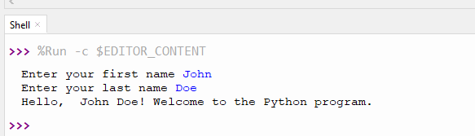
Submission Instructions:
- Please watch the following video and follow the steps shown in it to complete your assignment: Video Link: https://drive.google.com/file/d/1W7zBA-jT-4hc-pmCEpHLMEO6GipFXPv5/view
- Create a GitHub repository and upload your Python scripts (.py files).
- Ensure the repository includes a README.md file that describes the functionality of your programs.
- Add both Task 1 and Task 2 scripts in the same repository.
- Submit the link to your GitHub repository once uploaded.

Reference:
Follow the Python course - Module 2: Basic Python Concepts for additional guidelines and examples.
Note: Please test your project thoroughly and check all the validations and error handling prior to ensure it works as expected before submission.
You can always connect to the mentor using the chat support option for any doubts or queries!

